Pacific Region Staff College
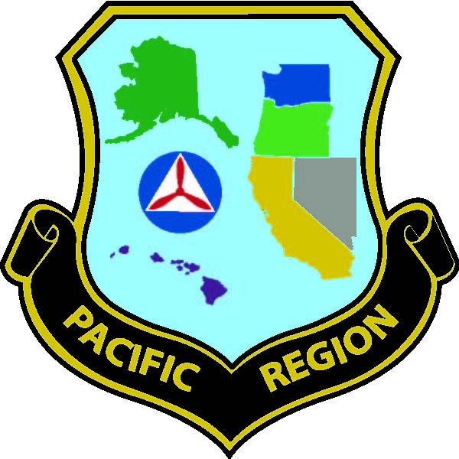

Nellis AFB, Las Vegas, NV

28 March - 3 April 2015

Pacific Region Staff College’s purpose is to prepare CAP officers to execute duties and responsibilities associated with command and staff positions, and is required for completion of Level IV.

Lectures & seminars cover interpersonal communication, leadership, management, and training techniques. PRSC is taught by a variety of highly qualified individuals who teach professionally, and/or are professionals in their civilian careers. Instructors are carefully selected based on their experience. PRSC is presented in a format friendly to all academic backgrounds.

This is the year for you to attend. Please reference CAPR 50-17 for student eligibility. Cost is $90.00 - includes course materials, Sunday night BBQ, Wednesday dinner social and Friday luncheon. PRSC staff will make room reservations on your behalf. Rates as of this printing are $56.00 per person, per night, and are the responsibility of the student. Nellis lodging accepts Visa and MasterCard. Please contact us regarding other billeting arrangements (e.g., off-base hotels) – locals may commute.

Deadline for Application: 8 March 2015
Submit one copy of your CAPF 17 through proper CAP channels for signatures (must be signed by your next highest level of command). Mail (or email) a copy to the address below along with a copy of your Senior Level Training record (obtain from e-Services) with your check for $90.00 payable to Pacific Region Staff College. If you need to pay by credit card, please contact me to arrange for that option.

2015 Staff College Registration Work: 650-849-5765

Lt Col Elizabeth J. Blackey Mobile: 650-678-0294
3553 Jefferson Avenue Email: eblackey@wsgr.com
Redwood City, CA 94062

NOTE: For your travel planning purposes, please keep in mind that the registration process will take place at 1000 hours on Saturday, 28 March; classes will begin at 1300. Friday, 3 April is a full class day (ending at 1700) so any flights should be planned either after 8:00 pm on 4/3, or any time on 4/4.

Check out our website at http://hc.pcr.cap.gov/pcrsc/, and our Facebook page at https://www.facebook.com/pages/Pacific-Region-Staff-College/141312259316598?ref=hl.

